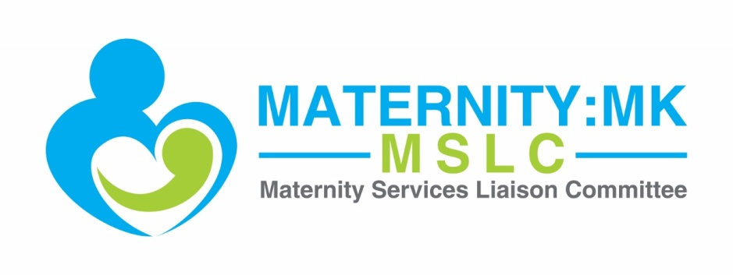

Maternity:MK
Maternity Services Liaison Committee (MSLC)
Annual Report July 2014 – July 2015

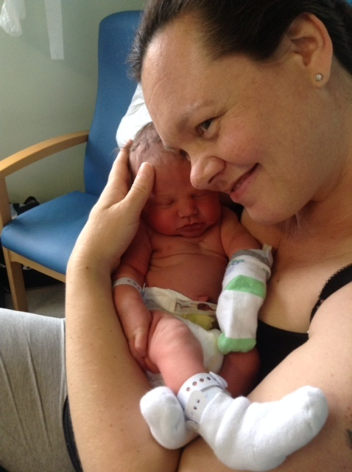

Table of Contents
- Background
- History
- How we work
- The Chair’s role
- Review of the year
- Funding arrangements
- Looking ahead
- Conclusion
- Recommendations for MKCCG
- Recommendations for MKUHFT
- Appendix

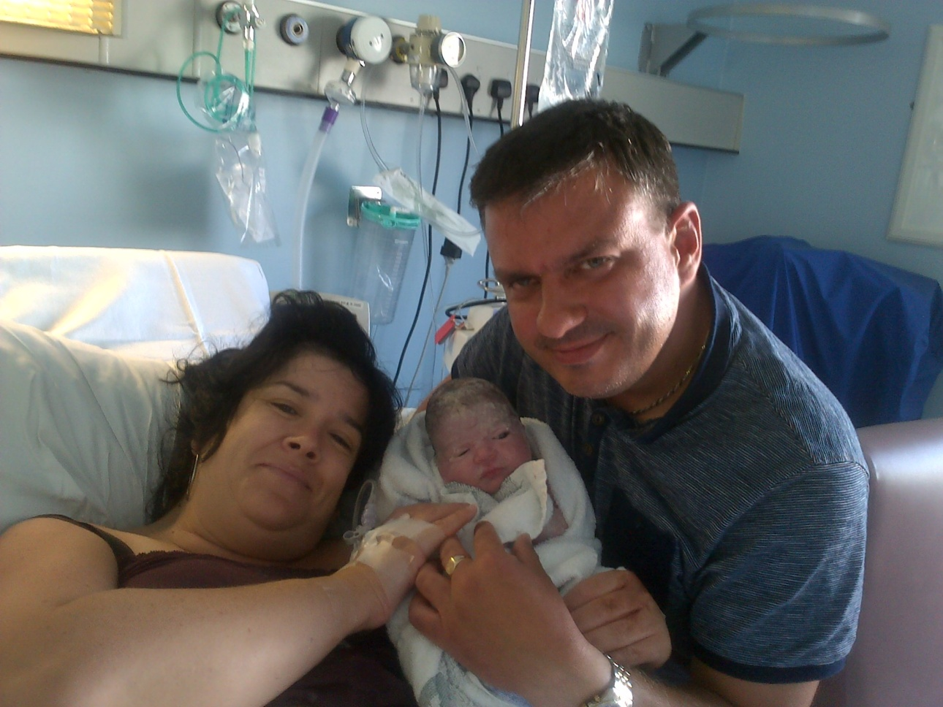
Our service user rep, Vicky Lawson, with her daughter, Esmae and partner, Garry.

Cover image: Our service user rep, Esther Leonards, with her son Anthony.
- Background
Maternity:MK is the Maternity Services Liaison Committee (MSLC) for Milton Keynes. Our remit is to act as an independent, multi-disciplinary advisory body to maternity commissioners and service providers in Milton Keynes. The committee is formed of those working within the maternity service provision, those using the maternity services, and the maternity commissioner. Our aim is to work together to discuss how maternity services are working for our local population and to advise on and drive forward necessary improvements. Our vision is to bring the voice of the service user to the core of all decisions made about the service by service providers and commissioners.
Maternity:MK is not a user group. The strength of MSLCs lie in their multi-disciplinary configuration. They enable a range of views to be fully integrated into decision-making.

MSLCs have a long history in the UK. Since 1983, MSLCs have been operating to ensure that the unique perspectives of maternity service users within the NHS (in most cases, healthy people experiencing a normal life event) are central to decisions made about maternity services.

‘No decision about me without me’.

Although much has changed since 1983, the need for the NHS to take account of service user views continues to be paramount. In 2010, The Department of Health reinforced this with their white paper, ‘Equity and excellence: liberating the NHS’ where we first heard the phrase ‘No decision about me without me’. The Health and Social Care Act (2012) emphasises the value of patients and carers involvement in planning, managing and decision making about their care and treatment and the effective participation of the public in the commissioning process itself, so that services reflect the needs of local people.

In 2006, The Department of Health published ‘National Guidelines for Maternity Services Liaison Committees’, which clearly outlines the role, remit and status of MSLCs. Since then, although the commissioning structures have changed, involving service users in planning, decision making and commissioning of health services continues to be a statutory requirement for the NHS (Health and Social Care Act, 2012), and the DH guidelines continue to be relevant. In 2013, NCT, RCM and RCOG published a consensus statement recommending that MSLCs continue to exist within the local health structure as the main means of giving service users influence over maternity strategy and service delivery. The consensus statement can be found at: https://www.nct.org.uk/sites/default/files/related_documents/MSLC%20document%20FINAL%202013%20V2.pdf. It is expected that in 2016 the DH will publish refreshed MSLC guidelines that will reflect these changes and reinforce the role of MSLCs within maternity structures.

The Kirkup Report (2015), following the Morcambe Bay Investigation, highlighted how crucial it is for Trusts to have a well-functioning MSLC in place. Recommendation 13 of the report stated, “The Trust should increase public and patient involvement in resolving complaints, in the case of maternity services, through the Maternity Services Liaison Committee”.

MSLCs have a long history of providing an effective means for maternity service users to influence the local provision of maternity services, and there is an abundance of policy and best practice guidance and recommendations in support of MSLCs.

- History
In July 2014 Maternity:MK was re-established as the MSLC for Milton Keynes, through a joint effort between service users and hospital Trust managers, after being dormant since the transition between PCTs and CCGs occurred.
- How we work
We meet bi-monthly at locations around Milton Keynes, including Children’s Centres and the Post-graduate Centre at the hospital, for two hours over lunchtime. All interested stakeholders are invited to contribute to the agenda which is circulated 1-2 weeks prior to each meeting. Minute-taking is provided by the hospital Trust at each meeting and the minutes are circulated to the core membership and other interested parties as soon as they become available.
Meetings are well attended by a range of health professionals and managers from provider organisations, service users, and the maternity commissioner from the CCG, with approximately one third representation from service users.
Maternity:MK is chaired by Leanne Stamp, a service user representative and Antenatal Educator. Leanne sets the agendas, coordinates the meetings and facilitates discussions at the meetings. When relevant, we welcome guest speakers to our meetings. It is expected that Maternity:MK members, where appropriate, take recommendations agreed at our meetings back to their places of work for implementation.
We work to an agreed Terms of Reference, which has been signed off by the maternity commissioner, Fiona West. Our Terms of Reference (revised September 2015) can be found in the Appendix.
We have established working groups to progress three key areas of work, which form the main part of our annual work plan. Our work plan can be found in the Appendix.

- The Chair’s role
The Chair’s activity over the past year has included, but is not limited to the following:
- Coordinate meetings (arrange venue, send invites, set agenda, collate and circulate papers)
- Chair meetings – facilitate discussion and small group work
- Review and circulate meeting minutes
- Maintain Maternity:MK email distribution list
- Facilitate the agreed work plan, coordinate working group activity, delegate tasks, as appropriate
- Build relationships and links with health professionals and the maternity commissioner; meet as necessary to discuss updates on service innovations and lobby for improvements based on user feedback and evidence-based research
- Attend meetings with providers, commissioners and other relevant agencies, as required
- Attend the annual LSA audit for Supervision of Midwives and attend the Head of Midwifery interviews
- Reply to emails and enquiries in a timely and professional manner
- Coordinate and oversee digital media communications, including Facebook, Twitter, and Maternity:MK website
- Draft Terms of Reference and annual work plan; review annually
- Draft Annual Report and present to the Trust and CCG Boards
- Network with other MSLC representatives around the country
- Recruit members / volunteers to the Maternity:MK committee
- Lobbying the CCG and other organisations for funding for Maternity:MK
Currently, the Chair role is completely voluntary. Leanne spends approximately 10 hours per week on Maternity:MK business, for which her time and expenses are not remunerated.
It is noted that in other areas with effective MSLCs, the chair role is sufficiently remunerated.

- Review of the year
Laying the groundwork
Much of the focus of our work over the past year has been on re-establishing the committee and laying the groundwork for a robust MSLC. Activity in this area has included:
- Establishing a presence on digital media and raising the profile of Maternity:MK through this channel; our Facebook page is https://www.facebook.com/maternityMK and on Twitter we are @maternitymk, with a combined total nearly 500 followers (and growing weekly)
- Designing a Maternity:MK website, www.maternitymk.co.uk
- Designing a logo for Maternity:MK, which is now used on all of our communications
- Coordinating and hosting a VOICES MSLC Team Development workshop in February 2015
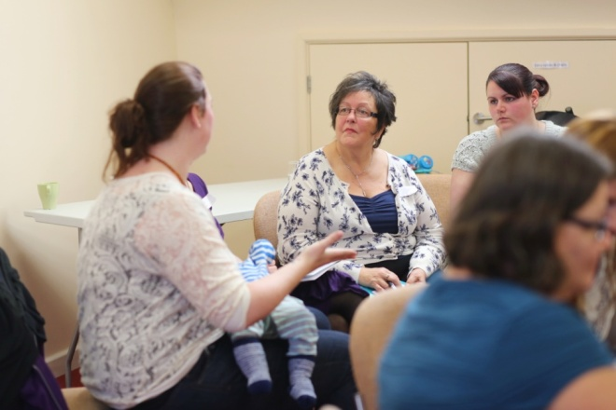
Progress and successes
The team are very proud of our achievements over the past year. We reflected on the year at our meeting in July 2015 and members’ comments are reflected in this Wordle:
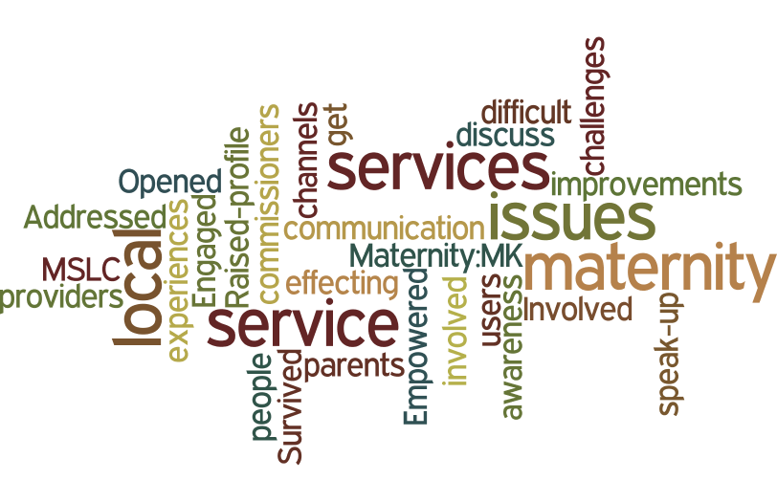
Some of the highlights of the year include:
- A case-study presentation from Gail Murphy, chair of Mid-Sussex MSLC, sharing the successes and challenges of her MSLC
- Contributing to the review of the draft Infant Feeding Policy
- On-going representation at the hospital Labour Ward Forum by one of our Maternity:MK service user reps
- A presentation from the CCG about the MK Healthcare Review and how it may impact on the work of Maternity:MK
- On-going representation at the Prenatal Mental Health Collaborative by three of our Maternity:MK service user reps
- Applying our learning from the VOICES team development day and identifying three main work areas; setting up working groups to progress these priorities
- Hosting a screening of the Microbirth film at the hospital Post-graduate Centre as a fundraiser for Maternity:MK
- Reviewing the results of the PICKER survey and making recommendations to the hospital Trust in response to the results
- Highlighting the issues for some women around partners not being allowed to be present during the siting of spinal anaesthesia for caesarean section; entering into discussions with the Trust to try to resolve these issues
- Distributing the Caesarean Experience survey designed by the Trust via the Maternity:MK Facebook page
- A presentation from Public Health about the Baby-friendly Initiative strategy for Milton Keynes community; recruiting a service user to represent Maternity:MK on the BFI Strategy Group on an ongoing basis
- Attendance at meetings and involvement in Maternity:MK activity continues to grow; our meeting in July 2015 was attended by over 20 stakeholders
- Funding arrangements
In 2014-15 Maternity:MK received £2000 in funding from the MK CCG to support the re-establishment of the committee. Whilst the CCG have agreed to support Maternity:MK in principle on an ongoing basis, they have not agreed to contribute any monies to Maternity:MK for 2015-16. Funding is an urgent issue for Maternity:MK. Without adequate funding the committee will not be able to continue to function in an effective capacity.
The consensus statement from NCT, RCM, and RCOG recommends that MSLCs are provided with a ring-fenced budget. Commissioners of maternity services have a statutory responsibility to involve service users in planning, decision making and commissioning of health services. Whilst, there is no statutory requirement in place to support a MSLC specifically to fulfil this function, we have been able to demonstrate that Maternity:MK is ideally placed to carry out this role for commissioners and providers for the benefit of maternity service users.
The CCG explored whether it could provide funding in 2015/16 to support Maternity:MK, however following a prioritisation exercise the CCG was not in a position to progress this. The CCG has identified that it is challenging to provide funding as there is no statutory requirement to do so, and as there is no history of providing funding to support service user groups or independent multi-disciplinary advisory groups.

The statutory body with which CCGs are required to engage is Healthwatch. The NCT, RCM and RCOG consensus statement (2013) recognises that Healthwatch is unlikely to be in a good position to represent the needs of maternity service users because historically, Healthwatch (and previously LINks) has been focussed on the needs of the elderly and patients with long-term medical conditions. Therefore MKCCG has agreed to support Maternity:MK in liaising with Healthwatch to discuss the interface between the organisations to ensure there are robust mechanisms in place to represent the needs of maternity service users.

- Looking ahead
With firm foundations laid and good momentum, Maternity:MK is in an ideal position to carry out its remit in 2015-16. The committee intends to focus on developing and progressing our work in the following areas:
- Continue to raise the profile of Maternity:MK by widely publicising the website and details of meetings and locations; design, print and distribute marketing materials
- Continue to progress the objectives of working groups
- Continue to work closely with the CCG maternity commissioner
- Team building and clearly defined user roles
- Continue to recruit representatives from all areas of the maternity provision (e.g. NNU, Anaesthetics)
- Secure adequate funding
- Develop systems for regularly capturing service user feedback, with a particular focus on hearing from “hard to reach groups”; and using this feedback to inform the service provision

- Conclusion
Maternity:MK is the MSLC for Milton Keynes, an independent, multi-disciplinary advisory body to the maternity commissioners and providers in Milton Keynes. We are not a service user group; our strength lies in the multi-discipline configuration, which allows us to consider a wide range of perspectives and experiences to inform our work. Our vision is to bring the voice of the service user to the core of all decisions made about local maternity services by service providers and commissioners. In light of the recommendations made by Kirkup (2015) and the wealth of policy and guidelines in support of service user engagement, our recent re-establishment in Milton Keynes is very timely.
Our aim is to work together to discuss how maternity services are working for our local population and to advise on and drive forward necessary improvements. Health care commissioners and providers have a statutory obligation to involve service users in planning, decision making and commissioning of health services and Maternity:MK is ideally placed to carry out this function in regard to maternity services in Milton Keynes.
The past year has seen Maternity:MK grow from strength to strength and we have laid the foundations for a robust MSLC, however inadequate funding continues to present limitations for our work. We have agreed work plans with a focus on effective engagement with service users, especially those from seldom heard groups, and continued partnership working with MK CCG and MKUHFT to ensure that the voice of the service user is truly at the core of our maternity service.
- Recommendations for MK CCG
- To ensure continued support and involvement of the maternity commissioner within the Maternity:MK team.
- To consider providing funding to Maternity:MK to enable us to gather quality service user feedback with representation from all socio-economic backgrounds in Milton Keynes and to operate effectively as per our remit.
- To support Maternity:MK in liaising with Healthwatch to discuss the interface between the organisations to ensure there are robust mechanisms in place to represent the needs of maternity service users.

- Recommendations for MKUHFT
- To ensure continued support and involvement of relevant MKUHFT staff.
- To continue to provide administrative support at Maternity:MK meetings.
- To increase the Trust board team’s understanding of the value of Maternity:MK in designing and delivering maternity care that is appropriate, effective and of high quality.
- To work with Maternity:MK to embed the MSLC at a strategic level within the decision making structures of the Trust to ensure that service user views and opinions, especially those from seldom heard groups, are at the core of maternity decision-making.
- To work with Maternity:MK to elicit service user feedback, with a particular focus on seeking out feedback from seldom heard groups.

- Appendix

Milton Keynes Maternity Services Liaison Committee (MSLC)
Maternity:MK
Terms of Reference 2014/15
Designing and delivering effective maternity care for women and their babies that is appropriate and meets their needs can be achieved more readily where commissioners, providers and service users work together. A formal committee is established in line with National Guidelines for Maternity Services Liaison Committees (MSLCs), February 2006 and the April 2013 consensus statement (RCOG, RCM and NCT). The committee is known as Maternity:MK to support the aim of increasing accessibility and engagement with the work of the group. Maternity:MK acts as a multi-disciplinary forum bringing together the different parties involved in maternity care, including providers, commissioners and service users.
“Women and their partners want a safe transition to parenthood and they want the experience to be positive and life enhancing. Quality maternity services should be defined by the ability to do both.”
Midwifery 2020: delivering expectations, 2010

- Vision for the MSLC
An effective, collaborative and dynamic committee of maternity service users,
providers and commissioners seeking to ensure that:
• The wishes, choices and unique physiological, emotional and
psychological needs of local women, their partners and babies are placed
at the centre of our local maternity services.
• Our local maternity services are of the highest quality and can be fully
accessed by all that need them.
• Local parents know about the MSLC, feel welcome to join and are aware of
the ways they can become involved.

2. The MSLCʼs purpose
An independent multi-disciplinary advisory body that exists to plan, monitor, develop, safeguard and improve local maternity services from pre-conception, throughout pregnancy, labour and the postnatal period to three months.

3. To achieve this the MSLC will:
  - Be user-led, with a user representative as chairperson and user representatives comprising at least one third of the core membership.
  - Create and follow an annual work plan and report the results of this work plan and associated recommendations to the Children and Maternity Programme Board (MKCCG) and Maternity Service Providers (Milton Keynes Hospital Foundation Trust).
  - Work collaboratively to progress the work plan via individually led pieces of work, specific short-term sub-groups and key decision makersʼ influence on service provision.
  - Listen to and respect each other’s diverse opinions and acknowledge that a wide range of experiences will inform particular viewpoints.
  - Seek out, listen to and respond to the opinions of local parents across all communities within Milton Keynes, making extra effort to discover the viewpoints of those less often heard in the debate about maternity services.
  - Share best practise with other areas, examine and review the latest evidence based-midwifery and obstetric research, as well as local and national developments, to ensure that local women and their families have access to the best quality maternity services.
  - Acknowledge the Department of Health Guidelines on good MSLC practice.

- Membership

  - Core Members are to be nominated by their organisations and commit to attending meetings regularly, to assign a deputy if this is not possible and report to and from their respective organisations on matters arising.
  - Others may be invited via the chairperson to attend meetings to speak or observe on an ad hoc basis as appropriate.
4.3 Parent Reps will represent local parents on the MSLC by leading a bi-monthly
community based meeting of parents from across the city (The MSLC Parent
Group). Dads are welcome and at least one Parent Rep should be a Father.
4.4 Babes in arms welcome at all meetings.
4.5 The email distribution list of meeting minutes will include those interested in the work of the MSLC but not currently named as Core Members.

5. Meetings
  - The MSLC will meet bi-monthly, at Milton Keynes Hospital, or MK CCG Headquarters in Bletchley, or a Children’s’ Centre, and will take place at user-friendly times convenient to MKHFT clinical staff and MK CCG staff.
  - The MSLC Parent Group will meet bi-monthly in the community at times convenient to the Parent Reps.
  - The MSLC Parent Group will act as a community forum for the MSLC, offering more parents an opportunity to input into the work of the MSLC and gathering broader opinions on local issues.
  - The MSLC Parent Group will be well publicised through social media, on websites and through parent groups.

6. The Chairperson
  - The chairperson will be a service user representative elected by the membership.
  - The chairperson will ensure the MSLC committee meetings run smoothly; ensure local users feedback is collected and communicated to service commissioners and provider; represent the MSLC and service users at maternity service meetings; and follow the agreed MSLC work plan.

7. Service Providers / Commissioners
  - The Service Provider (MKHFT) / Commissioners (MKCCG) will respect the collective voice of the MSLC and take into account the recommendations of the MSLC when designing services.
  - The Service Provider (MKHFT) / Commissioners (MKCCG) will support regular attendance from key staff who are MSLC members.
  - The Service Provider (MKHFT) / Commissioners (MKCCG) will invite the MSLC chairperson to attend meetings and events where the service users’ voice should be heard and accounted for.
  - The Service Provider (MKHFT) / Commissioners (MKCCG) will facilitate the work of the MSLC chairperson and co-operate in the MSLC work plan.

8. Committee proceedings

8.1 A quorum shall be one third of the full core MSLC membership, including deputies.

9. Annual report
9.1 The MSLC will produce an annual report that includes as a minimum:
The work of the MSLC over the past year
Progress on local strategies and targets
Work plan for the coming year based on identified priorities
Recommendations to the commissioner

10. Administration
10.1 MKHFT will provide administrative support for the MSLC.
10.2 The MSLC administrator will provide Core Members with meeting minutes, monthly maternity statistics, advance notice of meeting dates and the opportunity to contribute to the meeting agenda.
10.4 The MSLC administrator will distribute the meeting minutes from the MSLC and MSLC Parent Group meetings to an email list including Core Members and interested parties.

11. Core Membership
User Representation
11.1 Parent representatives
11.2 NCT representative
11.4 La Lèche League representative
11.5 Children’s Centres representative

Provider organisation representation – Milton Keynes Foundation Trust
11.6 Head of Midwifery
11.7 Consultant Midwife
11.8 Lead Consultant Obstetrician
11.9 Supervisor of Midwives
11.10 Lead Midwife for Midwifery Led Care
11.11 Community Midwifery Team Rep
11.12 Infant Feeding Specialist Midwife
11.13 Lead consultant paediatrician / neonatologist

Provider organisation representation – CNWL NHS Foundation Trust
11.14 Operational Manager – Health Visiting

Provider organisation representation – Newport Pagnell Health Visiting Team
11.15 Health Visitor Team Leader

Primary Care
11.16 GP lead
Commissioning Representation - MKCCG
  - Commissioning Lead for Children, Young People and Maternity Services

Other Representation that will be sought
  - Provider Service Managers
  - Public Health
  - Healthwatch Milton Keynes
  - Such other representation as helpful to delivery of the agenda

12. Distribution via email

As above plus:
12.1 MSLC admin support at MKHFT
12.2 Specialist midwives
12.3 PAs to CEO and Heads of Department at MKHFT
12.4 Interested parties in Milton Keynes area

13. Review Date
13.1 These Terms of Reference will be reviewed annually at year end.

Maternity:MK Work Plan 2015-16
(Updated by L Stamp - September 2015)
 | TASK | LEAD | PROGRESS TO DATE | DEADLINE
1 | To continue to raise the profile of Maternity:MK, generating interest, awareness and support from the hospital Trust, CCG, maternity care provider staff, relevant agencies and organisations (e.g. Healthwatch Milton Keynes Council), and maternity service users. | Chair | - Social media campaign underway  - Logo designed and being used in Maternity:MK communications  - Website published  - Links established with MKUHFT Board and lead staff, CNWLNHST lead staff, Healthwatch and Milton Keynes Council  - Meetings held bi-monthly around Milton Keynes with good stakeholder representation, including CCG, providers and service users | Ongoing
2 | To launch a system of gathering service user feedback on a regular basis; to increase public awareness of Maternity:MK and engagement with service users, with a particular focus on ‘seldom heard groups’ | TBC / Chair | - To initiate work in autumn 2015  - Ideas generated to increase public awareness e.g. The Centre:MK kiosk; Maternity:MK posters; Maternity roadshow; Maternity unit open day  - Ideas generated to gather service user feedback e.g. Parent Forums; Maternity road show; Digital surveys (i.e. via Facebook) | Ongoing
3 | To progress the objectives of Antenatal working group: To improve continuity of care from midwives in the antenatal period. | Antenatal working group Lead | - Established March 2015  - Working group is meeting on a regular basis  - Grainne Millwood attended Midwifery-led care and choice of place of birth conference in Birmingham (July 2015  - Recruitment drive to set-up a Home Birth team  - Home Birth team to run “Meet the Midwife” sessions (once team established) | Ongoing (timescale 12-18 months)
4 | To progress the objectives of Labour & Birth working group: To establish and midwife-led unit in Milton Keynes. | Labour & birth working group Lead | - Established March 2015  - Grainne Millwood attended Midwifery-led care and choice of place of birth conference in Birmingham (July 2015)  - Women’s centre development planned by Trust? - TBC with Anne Thysse | Ongoing (timescale 3 years)
5 | To progress the objectives of the Postnatal working group: To improve the Perinatal Mental Health provision in Milton Keynes. | Postnatal working group Lead | - Established March 2015  - Parent representatives from Maternity:MK attending Perinatal Mental Health Collaborative meetings, including mapping event in June 2015  - CCG has provided funding to set-up Perinatal Mental Health Service in MK  - Maternity:MK reps to continue to attend monthly meetings and contribute to development of integrated pathway document | Ongoing (timescale 1 year +)

Baby Eadie, born to our service user rep Natalie Jarmaine and her partner, John, at Milton Keynes Hospital in October 2015.

