Maternity:MK
Maternity Services Liaison Committee (MSLC)
Annual Report August 2015 – September 2016
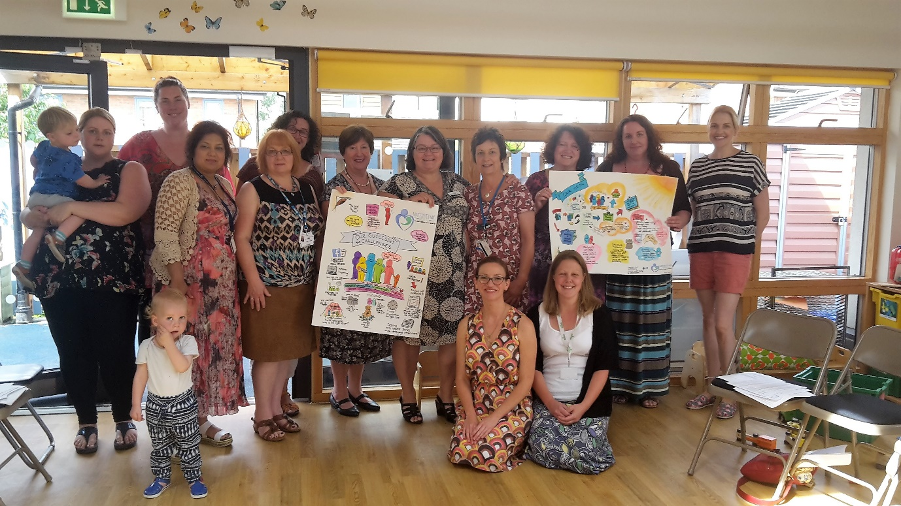

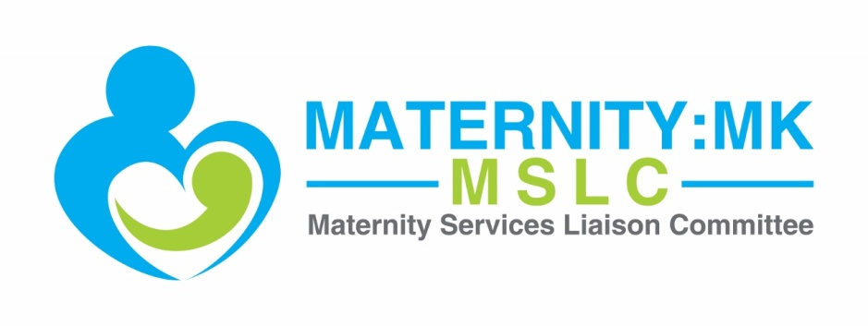
Table of Contents

- Why you need your Maternity Services Liaison Committee
- How we work
- The chair’s role
- Review of the year
- Funding arrangements
- Looking ahead
- Conclusion
- Recommendations for MKCCG
- Recommendations for MKUHFT
- References
- Appendix

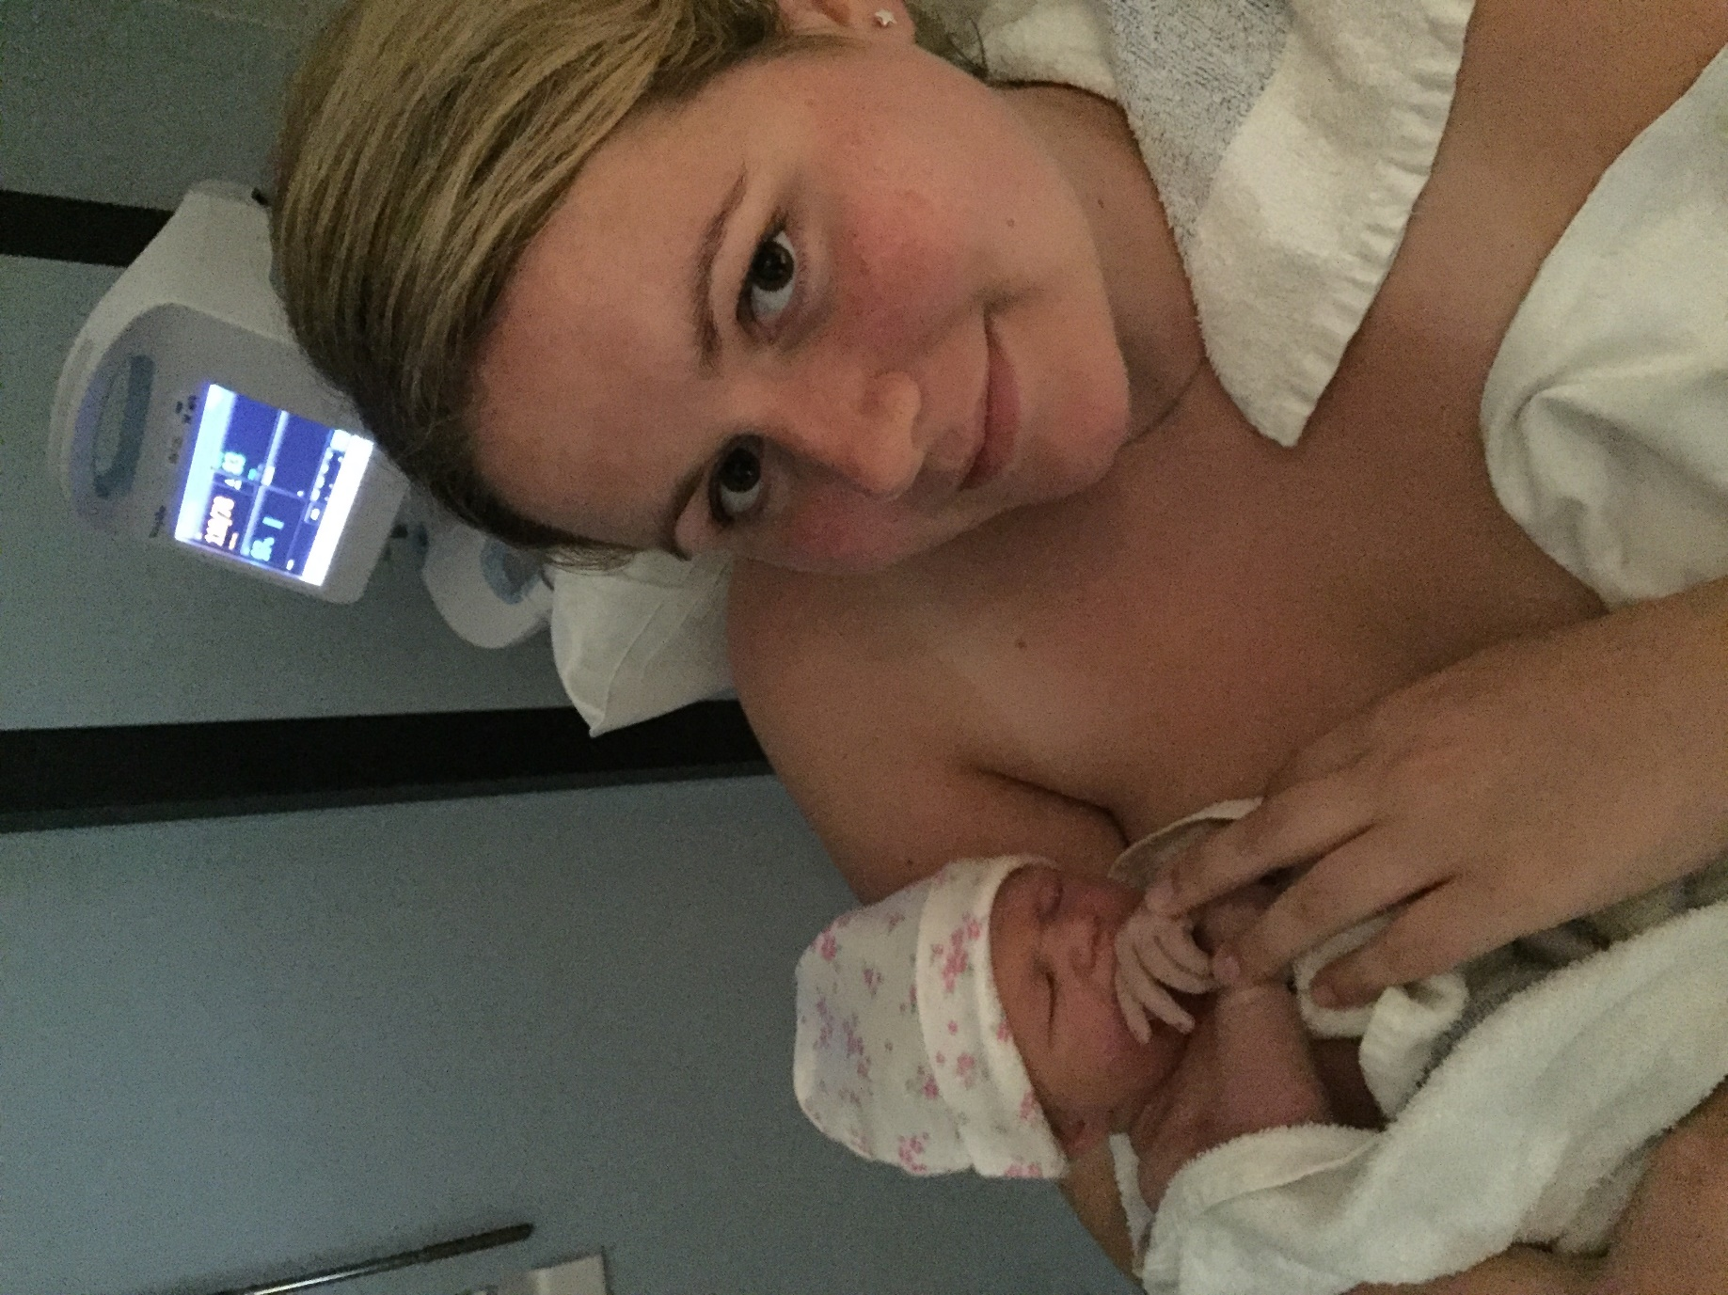
Our service user rep, Nikki Kenton, with her daughter, Ava, born at MKUH in July 2016.

Cover image: The Maternity:MK team, celebrating our work at our July 2016 meeting.
- Why you need your Maternity Services Liaison Committee
Maternity:MK is the Maternity Services Liaison Committee (MSLC) for Milton Keynes. Our remit is to act as an independent, multi-disciplinary advisory body to maternity commissioners and service providers in Milton Keynes. The committee is formed of those working within the maternity service provision, those using the maternity services, and the maternity commissioner. Our aim is to work together to review how maternity services are working for our local population and to plan and contribute to the development of these services. Our vision is to bring the voice of the service user to the core of all decisions made about the service by service providers and commissioners.
Maternity:MK is not a user group. The strength of MSLCs lie in their multi-disciplinary configuration. They enable a range of views to be fully integrated into decision-making.

‘Evidence suggests that engaging and involving communities in the planning, design and delivery of health and care services can lead to a more joined-up, co-ordinated and efficient services that are more responsive to local community needs. Public participation can also help to build partnerships with communities and identify areas for service improvement.’

Transforming participation in health and care: guidance for commissioners, NHS England (2013)

For over 30 years, MSLCs have been operating throughout the UK to ensure that the unique perspectives of maternity service users are integrated into decision making about NHS maternity services. ‘[The work of MSLCs], when well-supported by the NHS, is the lived commitment of service user representatives, commissioners and healthcare professionals to collaborative project work, and to making joint advisory recommendations on evidence-based commissioning.’ (Williams, 2015).
Today, the utility of MSLCs has never been greater. Involving service users collaboratively in the making decisions about health care services and driving forward improvements isn’t just good practice, it is the law.
The NHS Constitution
The NHS Constitution (2015) defines the rights, pledges and responsibilities of NHS patients and staff. It tells us that the NHS aspires to provide high quality care that is safe, effective and focused on patient experience. This requires ‘collective effort and collaboration at every level of the system’ and is dependent on welcoming feedback from patients and utilising feedback to drive forward improvements. Collaboration and patient involvement are crucial for delivering high quality care.
The Constitution also highlights the right of patients (service users) to be involved in decision-making about health care services:
‘You have the right to be involved, directly or through representatives, in the planning of healthcare services commissioned by NHS bodies, the development and consideration of proposals for changes in the way those services are provided, and in decisions to be made affecting the operation of those services.’
Transforming participation in health and care
Current guidance on patient and public involvement (NHS England, 2013), which exists to support the legal duties required of CCGs and NHS England, defines involvement as,
‘Working directly with communities and patients to ensure that concerns and aspirations are consistently understood and considered. ‘
And collaboration is defined as,
‘Working in partnership with communities and patients in each aspect of the decision, including the development of alternatives and the identification of the preferred solution’
Here in Milton Keynes, as in many other parts of the country, the mechanism for meaningful involvement and collaboration in maternity services, with service users, commissioners and provider staff working together exists as the Maternity Services Liaison Committee (Maternity:MK). In other words, Maternity:MK is a useful tool to meet the mandate of the NHS Constitution, for both those working in and those using NHS maternity services.
Further support for your MSLC
The NCT, RCM and RCOG

The NCT, RCM and RCOG recommend that MSLCs exist within the local health structure as the main means of giving service users influence over maternity strategy and service delivery (NCT, 2013). NCT currently supports a robust network of MSLC leaders throughout the country, which exists for support and sharing of good practice.

NICE guidance

NICE guideline CG190, Intrapartum care for healthy women and babies (2014), recommends that commissioners and providers should ensure that there are multidisciplinary clinical governance structures in place, which include adequately supported user representation, to oversee birth settings, (rec 1.1.17).

Strategic Clinical Network

The Thames Valley Strategic Clinical Network, in its recently published conclusion paper on maternity capacity and future planning (Herve and Furlong, 2016), recommends that ‘women and their families are included in maternity planning so they are truly engaged and understand the complexities of service planning and delivery.’

The Kirkup report (2015)

Recommendation 13 of Kirkup’s (2015) report, following the Morcambe Bay Investigation stated, ‘The Trust should increase public and patient involvement in resolving complaints, in the case of maternity services, through the Maternity Services Liaison Committee’, and highlighted how important it is for Trusts to have a well-functioning MSLC in place.

Implementing the Five year forward view: Better Births and The Maternity Transformation Programme

In 2016, the National Maternity Review published Better Births, which stated that ‘services should be designed in a way which put women, their babies and families at the centre.’ The review identified MSLCs, when well supported and led, as a mechanism for ensuring the needs of women and professionals are taken into account when planning and delivering services.

NHS England has set out the Five year forward view for transforming maternity services in England to implement the recommendations of Better Births. In these plans, involvement of women and their families is central within the proposed Local Maternity Systems (LMS), the local agents for delivering Better Births. NHS England is expected to publish updated guidelines for MSLCs in early 2017, accompanied by an implementation strategy, that will support MSLCs as the mechanism for involving service users in the transformation of LMS.

- How we work

In 2015, we reported that Maternity:MK was re-established as the MSLC for Milton Keynes in 2014, as a collaborative effort between service users and NHS staff. Since our last report, Maternity:MK has continued to develop as a team, working collaboratively to raise our profile and extend reach in Milton Keynes.
We continue to meet bi-monthly in Children’s Centres and Family Centres around Milton Keynes. Stakeholders are invited to contribute to the agenda which is normally circulated one week prior to each meeting. Minute-taking is provided by MKUHFT at each meeting and the minutes are circulated to the core membership and other interested parties as soon as they become available.
Meeting attendance continues to be very enthusiastic, with up to 20 attendees, including a range of health professionals from provider organisations; service users; and the maternity commissioner from the CCG; with approximately one third representation from service users.
Leanne Stamp, a service user representative and Antenatal Educator, is Chair of Maternity:MK. Leanne sets the agendas, coordinates the meetings and facilitates discussions at the meetings. We welcome guest speakers to our meetings, as appropriate. It is expected that Maternity:MK members take recommendations agreed at our meetings back to their places of work for implementation.
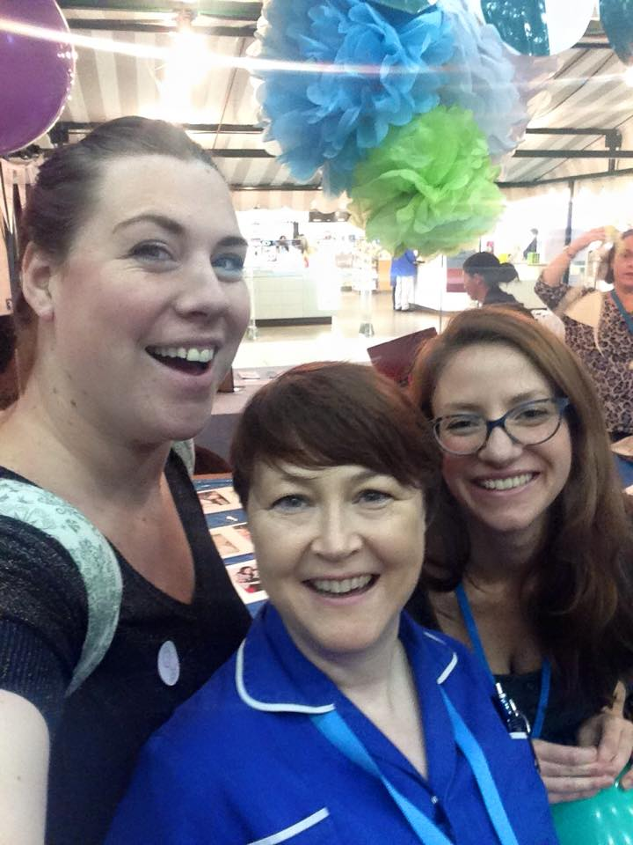
We work to an agreed Terms of Reference (see Appendix) and an ongoing plan of work.

- The chair’s role
Our Chair, Leanne, continues to carry out her role as described in our 2014-15 report, which involves both chairing the committee and coordinating the work of Maternity:MK. The Chair role continues to be voluntary. Leanne spends on average 7.5 hours per week on Maternity:MK business.

- Review of the year
Artwork by Michaela Finegan
Last year, we reported about our work in 2014-15 to lay the foundations for a robust MSLC. In 2015-16 we were able to utilise these foundations to continue to grow as a team, raise the profile of Maternity:MK and extend our reach in Milton Keynes through collaborative working.
Achievements
In July 2016, the team organised a planning and development workshop with the aims of celebrating our strengths, progress and successes; identifying barriers to success; and agreeing our work priorities for 2016-17. The workshop was attended by 15 service users and clinicians and was facilitated by Hannah Pugliese, Children, Young People and Maternity Commissioner (MK CCG). The work during the workshop was recorded visually by Michaela Finegan, Patient Experience Manager (MKUHFT). As a group, we reflected on our successes over the past year:

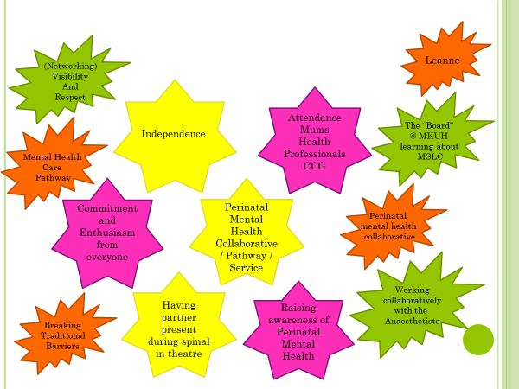
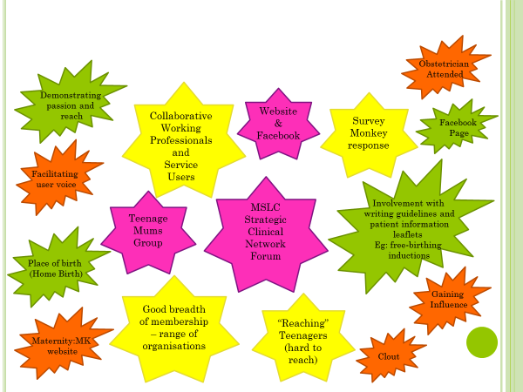

Some of our achievements include:
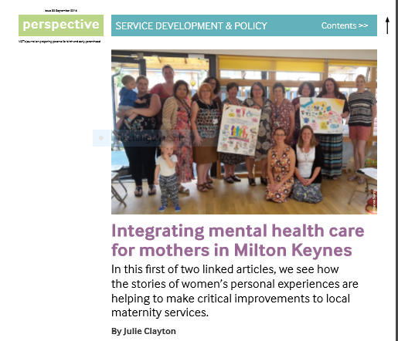
- Supporting the work of the MK Perinatal Mental Health Collaborative (PMHC), to develop a pathway and perinatal mental health service in MK. Our service user representatives are part of the collaborative and have been key to ensuring that the pathway and service will meet the needs of women and their families. Our work with the PMHC is ongoing as they move toward service roll-out and evaluation. The success of our collaborative work was reported in the September 2016 issue of Perspective, the journal for NCT practitioners.
- Representing women and their families on The Baby-friendly Initiative Strategy Group, led by Public Health at Milton Keynes Council. Our work with the group is ongoing as they work toward rolling-out the BFI in the community.
- Representing women and their families at The Thames Valley and Milton Keynes Maternity Network Service User Forum (run jointly by the Thames Valley Strategic Clinical Network and Oxford Academic Sciences Network and the Nuffield Department of Obstetrics and Gynaecology), which meets three times per year with the aim of enabling the network partners to ensure their work is developed in conjunction with maternity service user’s views. Our work with the forum is ongoing.
- Visiting the Young Parents’ group in New Bradwell to get feedback about their maternity care experiences.
- Using women’s voices to influence changes in practice at MK hospital around caesarean birth experience (as featured on BBC Three Counties Radio 15 March, 2016).
- Representing women and their families on maternity issues during the Beds-MK Healthcare Review consultation process.
- Using women’s voices to influence changes in service provision in community midwifery with the introduction of a dedicated home birth team.
- Exhibiting at Healthwatch 2015 to raise the profile of Maternity:MK and collect feedback from women about their experiences of maternity care.
- Involving service users in the development of a guideline and patient information leaflet about Free-birthing.
Challenges
- Understanding why some groups of healthcare professionals are less engaged (e.g. doctors)
- Engaging with the broadest range of service users possible
- Using feedback effectively
- Managing and recruiting volunteers
The over-arching challenge that we face currently is a shortage of resources. Since 2014-15, Maternity:MK has not received any additional funding from the NHS. Despite tremendous enthusiasm and dedication, without the allocation of sufficient resources, the sustainability of the MSLC is dubious. Currently, the service user input (which makes up one third of the core membership of the committee, including the chair/coordinator role), and is the crux of the MSLC, is done on good will. In other areas with robust and thriving MSLCs, for example Reading, Wokingham and West Berks Maternity Forum, the CCGs provide a budget sufficient to remunerate the chair/coordinator for her time, as well as meet the travel and childcare expenses of service users attending meetings and facilitating focus groups.
- Looking ahead
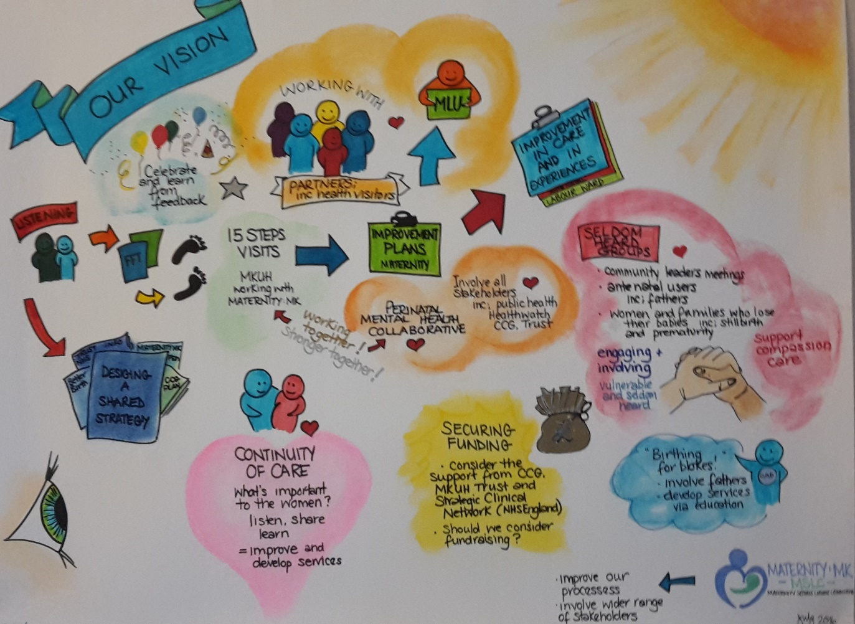
Artwork by Michaela Finegan

The committee has agreed to focus on developing and progressing our work in the following areas in 2016-17:
  - Broadening our reach to engage with and elicit feedback from seldom heard groups of parents, including BME groups, partners, and parents who have lost their babies.
  - Utilising service user feedback to drive forward improvements to postnatal care, particularly care on the wards, and caesarean recovery.
  - Continuing to support the work of the MK Perinatal Mental Health Collaborative to ensure that its work reflects the views and needs of service users.
These work areas reflect recommendations of the Better Births report and the focus of The National Maternity Transformation Programme. We are working closely with the Maternity Commissioner (MK CCG) and the Head of Midwifery (MKUHFT) to work towards the implementation of The Five Year Forward View, ensuring that service users views and needs are integral to the process.

- Conclusion
Maternity:MK, the MSLC for Milton Keynes, is an independent, multidisciplinary advisory body to the maternity commissioners and providers. Our vision is to bring the voice of the service user to the core of all decisions made about local maternity service. The key to the success of the MSLC is its multidisciplinary configuration and service user involvement in service development and delivery through collaboration and co-design.
Health care commissioners and providers have a statutory obligation to involve service users in planning, decision making and commissioning of health services, as mandated by the NHS Constitution. It is widely recognised that service user involvement in maternity services is essential. Better Births identifies MSLCs as the mechanism for ensuring the needs of women and professionals are taken into account when planning and delivering services. Here in Milton Keynes, this mechanism is already established.
In the past year, we have continued to grow and develop, despite a lack of adequate resources. Funding continues to be a barrier and we will continue to campaign for the provision of adequate funding to support a sustainable and robust MSLC, particularly considering the ambitions of the Maternity Transformation Programme.
We work to an agreed plan of work, with a focus on three key areas, including engaging with seldom heard groups; using service user feedback to drive forward improvements to postnatal care; and ensuring that service user views and needs are incorporated into the work of the Perinatal Mental Health Collaborative. Our work is aligned with Better Births and we are working closely with the CCG and the hospital to ensure that local implementation of The Maternity Transformation Programme reflects the views and needs of local women and families.
- Recommendations for MK CCG
- To ensure continued support and involvement of the maternity commissioner within the Maternity:MK team.
- To consider providing funding to Maternity:MK to enable us to gather quality service user feedback with representation from all socio-economic backgrounds in Milton Keynes and to operate effectively as per our remit.
- To work collaboratively with Maternity:MK to implement and monitor the recommendations of Better Births and the Maternity Transformation Programme.
- To work collaboratively with Maternity:MK to progress developments and improvements in our key work areas.

- Recommendations for MKUHFT
- To continue to ensure continued support and involvement of relevant MKUHFT staff, including the provision of administrative support at Maternity:MK meetings.
- To review how maternity service user views are integrated into the decision-making structures of the Trust at a strategic level, and to work with Maternity:MK to ensure that service user views, especially those from seldom heard groups, are at the core of decision-making about maternity services.
- To work with Maternity:MK to elicit service user feedback, with a focus on seeking out feedback from seldom heard groups.
- To work collaboratively with Maternity:MK to implement and monitor the recommendations of Better Births and the Maternity Transformation Programme.
- To work collaboratively with Maternity:MK to progress developments and improvements in our key work areas.
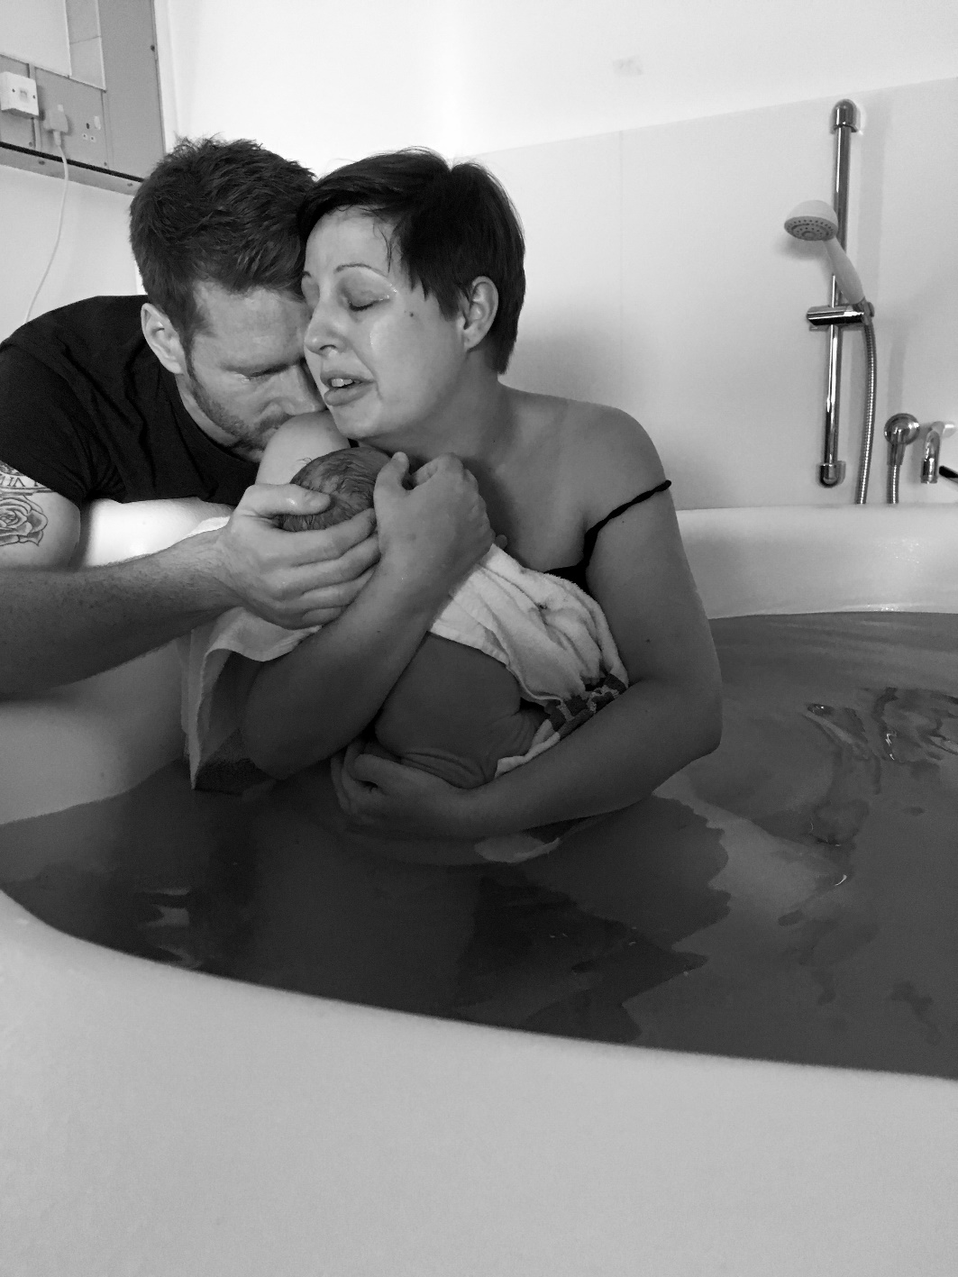
Our service user rep, April Austin, with partner, Marc, and baby, Aiden, born at MKUH in June 2016.
“For me this photo is a representation of the support I received. My baby born in water after two caesareans. My husband with me, midwives and doula just holding my space and allowing me to birth in the right way for me. It was outside of guidelines and could be considered controversial but that moment represents all the sadness and regret that came before and all the love and confidence that has come since Aiden's birth. I am ever grateful for the amazing support for midwives I received before, during and after Aiden's birth.” - April

- References
Transforming participation in health and care: guidance for commissioners, NHS England (2013). Available at: https://www.england.nhs.uk/2013/09/trans-part/

How maternity services liaison committees (MSLCs) work in the UK, Williams (2015) in Essentially MIDIRS, April 2015, vol. 6, no. 3. Available at: https://birthandbiology.files.wordpress.com/2015/10/em-april-2015-williams.pdf

NHS Constitution for England, Department of Health (2015). Available at: https://www.gov.uk/government/publications/the-nhs-constitution-for-england

Maternity services liaison committees (MSLCs): a consensus statement from NCT, RCM and RCOG, NCT (2013). Available at: https://www.nct.org.uk/sites/default/files/related_documents/MSLCs%20consensus%20statement%20NCT%2C%20RCM%2C%20RCOG.pdf

Intrapartum care for healthy women and babies, clinical guideline [CG190], NICE (2014). Available at: https://www.nice.org.uk/guidance/cg190?unlid=9529741492016121984621

TVSCN maternity capacity and future planning report, Herve and Furlong (2016). Available at http://tvscn.nhs.uk/wp-content/uploads/2016/06/Final-TVSCN-Maternity-Capcity-Report-9.6.16-v-35.pdf.

The report of the Morcambe Bay investigation, Kirkup (2015). Available at: https://www.gov.uk/government/uploads/system/uploads/attachment_data/file/408480/47487_MBI_Accessible_v0.1.pdf

Better Births: improving outcomes of maternity services in England, National Maternity Review (2016). Available at: https://www.england.nhs.uk/wp-content/uploads/2016/02/national-maternity-review-report.pdf

10. Appendix

Milton Keynes Maternity Services Liaison Committee (MSLC)
Maternity:MK
Terms of Reference 2016-2017
Designing and delivering effective maternity care for women and their babies that is appropriate and meets their needs can be achieved more readily where commissioners, providers and service users work together. A formal committee is established in line with National Guidelines for Maternity Services Liaison Committees (MSLCs), February 2006 and the April 2013 consensus statement (RCOG, RCM and NCT). The committee is known as Maternity:MK to support the aim of increasing accessibility and engagement with the work of the group. Maternity:MK acts as a multi-disciplinary forum bringing together the different parties involved in maternity care, including providers, commissioners and service users.
“Women and their partners want a safe transition to parenthood and they want the experience to be positive and life enhancing. Quality maternity services should be defined by the ability to do both.”
Midwifery 2020: delivering expectations, 2010

- Vision for the MSLC
An effective, collaborative and dynamic committee of maternity service users,
providers and commissioners seeking to ensure that:
• The wishes, choices and unique physiological, emotional and
psychological needs of local women, their partners and babies are placed
at the centre of our local maternity services.
• Our local maternity services are of the highest quality and can be fully
accessed by all that need them.
• Local parents know about the MSLC, feel welcome to join and are aware of
the ways they can become involved.

2. The MSLCʼs purpose
An independent multi-disciplinary advisory body that exists to collaboratively review how maternity services are working for our local population and to plan and contribute to the development of these services.
3. To achieve this the MSLC will:
  - Be user-led, with a user representative as chairperson and user representatives comprising at least one third of the core membership.
  - Create and follow an annual work plan and report the results of this work plan and associated recommendations to the Children and Maternity Programme Board (MKCCG) and Maternity Service Providers (Milton Keynes Hospital Foundation Trust).
  - Work collaboratively to progress the work plan via individually led pieces of work, specific short-term sub-groups and key decision makers’ influence on service provision.
  - Listen to and respect each other’s diverse opinions and acknowledge that a wide range of experiences will inform viewpoints.
  - Seek out, listen to and respond to the opinions of local parents across all communities within Milton Keynes, making extra effort to discover the viewpoints of those less often heard in the debate about maternity services.
  - Share best practise with other areas, examine and review the latest evidence based-midwifery and obstetric research, as well as local and national developments, to ensure that local women and their families have access to the best quality maternity services.
  - Acknowledge the Department of Health Guidelines on good MSLC practice.
- Membership

  - Core Members are to be nominated by their organisations and commit to attending meetings regularly, to assign a deputy if this is not possible and report to and from their respective organisations on matters arising.
  - Others may be invited via the chairperson to attend meetings to speak or observe on an ad hoc basis as appropriate.
4.3 Parent Reps will represent the views of local parents on the MSLC Dads and partners are encouraged to attend.
4.4 Babes in arms welcome at all meetings.
4.5 The email distribution list of meeting minutes will include those interested in the work of the MSLC but not currently identified as Core Members.
5. Meetings
  - The MSLC will meet bi-monthly, at Milton Keynes Hospital, or MK CCG Headquarters in Bletchley, or a Children’s or Family Centre, and will take place at user-friendly times convenient to clinical and CCG staff and parents.
6. The Chairperson
  - The chairperson will be a service user representative elected by the membership.
  - The chairperson will ensure the MSLC committee meetings run smoothly; ensure local users’ feedback is collected and communicated to service commissioners and provider; represent the MSLC and service users at maternity service meetings; and follow the agreed MSLC work plan.
6.3 The chairperson will provide Core Members with meeting minutes, notice of meeting dates and the opportunity to contribute to the meeting agenda.
6.4 chairperson will distribute the meeting minutes from the MSLC meetings to an email list including Core Members and interested parties.

7. Service Providers and Commissioners
  - The Service Provider organisations include MKUHFT, CNWL.
  - The Commissioning organisations are MK CCG and Milton Keynes Council (Public Health).
  - The Service Providers and Commissioners will respect the collective voice of the MSLC and take into account the recommendations of the MSLC when designing services.
  - The Service Providers and Commissioners will support regular attendance from key staff who are MSLC members.
  - The Service Provider and Commissioners will invite the MSLC chairperson and / or service user reps to attend meetings and events where the service users’ voice should be heard and accounted for.
  - The Service Provider and Commissioners will facilitate the work of the MSLC chairperson and co-operate in the MSLC work plan.

8. Committee proceedings
8.1 A quorum shall be one third of the full core MSLC membership. This may include deputies, and must include at least two service user representatives (including the chair).
9. Annual report
9.1 The MSLC will produce an annual report that includes as a minimum:
The work of the MSLC over the past year
Progress on local strategies and targets
Work plan for the coming year based on identified priorities
Recommendations to the commissioner
10. Administration
10.1 MKUHFT will provide administrative support at Maternity:MK meetings for minute taking.
10.2 Minutes will be drafted by the MKUHFT administrator and provided to the chairperson for circulation to the membership within one week of each meeting.
11. Core Membership
User Representation
11.1 Parent representatives
11.2 Service user representatives from organisations providing parent support, including but not limited to : NCT, Doulas MK, La Leche League.

Provider organisation representation – Milton Keynes University Foundation Trust
11.6 Head of Midwifery
11.7 Consultant Midwife
11.8 Lead Consultant Obstetrician
11.9 Supervisor of Midwives
11.11 Community Midwifery team rep
11.12 Infant Feeding Lead Midwife
11.13 Lead consultant paediatrician / neonatologist
11.14 Women’s health physiotherapist

Provider organisation representation – CNWL NHS Foundation Trust
11.14 Operational Manager – Health Visiting
11.15 Infant Feeding Coordinator
11.16 Perinatal Mental Health team rep

Provider organisation representation – Newport Pagnell Health Visiting Team
11.16Health Visitor Team Leader
Primary Care
11.17 GP lead
Commissioning Representation
11.19 Commissioning Lead for Children, Young People and Maternity Services – Milton Keynes Clinical Commissioning Group
11.20 Public Health Practitioner – Milton Keynes Council (Public Health)

Healthwatch Milton Keynes
11.20 Authorised Healthwatch Representative

Other Representation that will be sought
11.21 Provider Service Managers
11.22 Children’s Centres representative

11.23 Such other representation as helpful to delivery of the agenda

12. Distribution via email

As above plus:
12.1 MSLC admin support at MKUHFT
12.2 Specialist midwives
12.3 PAs to CEO and Heads of Department at MKUHFT
12.4 Interested parties in Milton Keynes area

13. Review Date
13.1 These Terms of Reference will be reviewed annually at year end.

